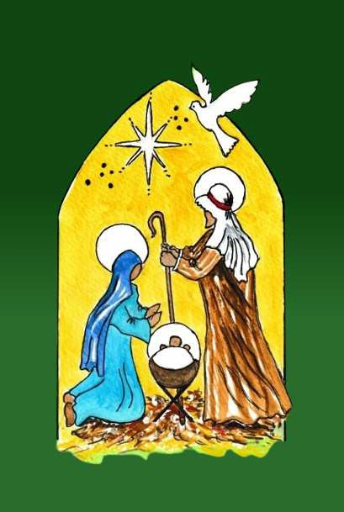
Your order A B
Complete the order and payment forms below. Then post it to: Mrs Brenda Beardwood, The Friends of Potter’s Village
4 Cranford Gardens, Marple, Stockport, SK6 6QQ

Title………………………………...
First Name……………………………………………….Surname…………………………………………………

Email address…………………………………………………………………...Telephone No……………………………………………………………

Gift Aid
I conﬁrm I have paid or will pay an amount of Income Tax and/or Capital Gains Tax for the current tax year (6 April to 5 April) that is at least equal to the amount of tax that all the charities and Community Amateur Sports Clubs (CASCs) that I donate to will reclaim on my gifts for the current tax year. I understand that other taxes such as VAT and Council Tax do not qualify. I understand the charity will reclaim 25p of tax on every
£1 that I have given.

Date: ……/……/20.... Signature………………………………………………..
Address……………………………………………………………………………………………………………………………………

………………………………………………………………………………...Postcode………………………………………………..
Payment—please
Cheque — I enclose a cheque for the total amount of: £ made
payable to Friends of Potter’s Village
I have made a direct Bank Transfer of £ direct to Friends of Potter’s Village
Bank Account, please use these details: Name of Bank CAF Bank; Acc. No.: 00031403
Sort code: Sort Code: 40-52-40

Your chosen gifts—order form

 | Gift No. | Item Description | Cost | Quantity | Total | Gift Card A or B
example | 13 | 3 ns of formula milk | £20 | 2 | £40 | A
Gift 1
Gift 2
Gift 3
Gift 4
Gift 5
Gift 6
Gift 7

