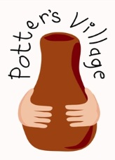
Donation requests for Potter’s Village.

For the children

Baby grows- from premature (1kg) to 2 year old size, poppered down the front if possible.
Baby vests/short sleeved vests – from premature (1kg) to 1 year old size.
Clothes for 1-5 year olds – skirts, trousers, t-shirts, dresses etc.
Cloth/reusable/washable nappies – birth to 12 months.
Plastic pants to go over nappies.
Muslins.
Bibs.
Baby bottles – small and large (with embossed not printed measurements if possible).
Teats for newborn babies.
Cot and small bed sheets.
Face flannels.
Plastic or wooden toys which can be easily wiped clean for babies to 3 year olds.
Knitted items – cot blankets, jumpers and cardigans with long sleeves (newborn – 3yrs).
Heavy duty plastic gloves
Bottle brushes

Posting parcels from the UK
The cheapest way is to keep the parcel under 2kg in weight and use International Economy Post at the Post Office. (can take up to 8 weeks to arrive). Do ensure that they are well wrapped. Put both the sender’s and the receiver’s address inside the parcel as well as on the outside.

Items don’t have to be new. Good quality, clean used items are most welcome

